**Divisjon:** Mønster – damer yngre junior – blått og rødt belte – **5 deltakere**

|  |  |  |  |  |  |  |  |  |  |  |
| --- | --- | --- | --- | --- | --- | --- | --- | --- | --- | --- |
| **Pool A** | | | | | | | | | | |
|  | **Navn** | **Klubb** | **1** | **2** | **3** | **4** | **5** | **Seire** | **Poeng** | **Plass** |
| **1** | Mina Bratterud | ATN Tromsø |  |  |  |  |  |  |  |  |
| **2** | Helle Schrøder Leiros | Tromsø NTN |  |  |  |  |  |  |  |  |
| **3** | Ragna Knoff | ATN Tromsø |  |  |  |  |  |  |  |  |
| **4** | Bente Solberg Larsen | Kirkenes NTN |  |  |  |  |  |  |  |  |
| **5** | Martine Solhaug | ATN Tromsø |  |  |  |  |  |  |  |  |

|  |  |  |  |  |  |  |  |  |  |  |  |  |  |  |  |  |  |  |  |  |
| --- | --- | --- | --- | --- | --- | --- | --- | --- | --- | --- | --- | --- | --- | --- | --- | --- | --- | --- | --- | --- |
| **Kamp nr.** | **1** | | **2** | | **3** | | **4** | | **5** | | **6** | | **7** | | **8** | | **9** | | **10** | |
| **Rød | Blå** | **4** | **5** | **1** | **2** | **3** | **4** | **1** | **5** | **2** | **3** | **1** | **4** | **2** | **5** | **1** | **3** | **2** | **4** | **3** | **5** |
| **Resutat** |  | |  | |  | |  | |  | |  | |  | |  | |  | |  | |

|  |  |
| --- | --- |
| **Resultat** | |
| **1** |  |
| **2** |  |
| **3** |  |

**Divisjon:** Mønster – damer yngre junior – gult og grønt belte – **9 deltakere**

|  |  |  |  |  |  |  |  |  |  |  |
| --- | --- | --- | --- | --- | --- | --- | --- | --- | --- | --- |
| **Pool A** | | | | | | | | | | |
|  | **Navn** | **Klubb** | **1** | **2** | **3** | **4** | **5** | **Seire** | **Poeng** | **Plass** |
| **1** | Nora Unosdatter Mortensen | Kirkenes NTN |  |  |  |  |  |  |  |  |
| **2** | Adelen Fjelde | Vardø NTN |  |  |  |  |  |  |  |  |
| **3** | Tuva Valvatne | Kirkenes NTN |  |  |  |  |  |  |  |  |
| **4** | Sandra Gundersen | Alta NTN |  |  |  |  |  |  |  |  |
| **5** | Ronja Elverum | Vardø NTN |  |  |  |  |  |  |  |  |

|  |  |  |  |  |  |  |  |  |  |  |  |  |  |  |  |  |  |  |  |  |
| --- | --- | --- | --- | --- | --- | --- | --- | --- | --- | --- | --- | --- | --- | --- | --- | --- | --- | --- | --- | --- |
| **Kamp nr.** | **1** | | **2** | | **5** | | **6** | | **9** | | **10** | | **13** | | **14** | | **15** | | **16** | |
| **Rød | Blå** | **4** | **5** | **1** | **2** | **3** | **4** | **1** | **5** | **2** | **3** | **1** | **4** | **2** | **5** | **1** | **3** | **2** | **4** | **3** | **5** |
| **Resutat** |  | |  | |  | |  | |  | |  | |  | |  | |  | |  | |

|  |  |  |  |  |  |  |  |  |  |
| --- | --- | --- | --- | --- | --- | --- | --- | --- | --- |
| **Pool B** | | | | | | | | | |
|  | **Navn** | **Klubb** | **1** | **2** | **3** | **4** | **Seire** | **Poeng** | **Plass** |
| **1** | Nina Friskilæ | Kirkenes NTN |  |  |  |  |  |  |  |
| **2** | Celina Wilhelmsen | Vardø NTN |  |  |  |  |  |  |  |
| **3** | Purnima Gurung | Kirkenes NTN |  |  |  |  |  |  |  |
| **4** | Christine Bønå Johannessen | Kirkenes NTN |  |  |  |  |  |  |  |

|  |  |  |  |  |  |  |  |  |  |  |  |  |
| --- | --- | --- | --- | --- | --- | --- | --- | --- | --- | --- | --- | --- |
| **Kamp nr.** | **3** | | **4** | | **7** | | **8** | | **11** | | **12** | |
| **Rød | Blå** | **1** | **2** | **3** | **4** | **2** | **3** | **1** | **4** | **1** | **3** | **2** | **4** |
| **Resutat** |  | |  | |  | |  | |  | |  | |

|  |  |  |  |  |  |  |
| --- | --- | --- | --- | --- | --- | --- |
| **Semifinale 1** | |  |  |  | |  |
| **17** | **A1:** |  |  |  | |  |
| **B2:** |  |  | **Finale** | |
|  |  |  |  | **19** |  |
|  |  |  |  |  |
| **Semifinale 2** | |  |  |  |  |
| **18** | **A2:** |  |  |  |  |
| **B1:** |  |  |  |  |

|  |  |
| --- | --- |
| **Resultat** | |
| **1** |  |
| **2** |  |
| **3** |  |
| **3** |  |

**Divisjon:** Mønster – damer junior – rødt belte – **5 deltakere**

|  |  |  |  |  |  |  |  |  |  |  |
| --- | --- | --- | --- | --- | --- | --- | --- | --- | --- | --- |
| **Pool A** | | | | | | | | | | |
|  | **Navn** | **Klubb** | **1** | **2** | **3** | **4** | **5** | **Seire** | **Poeng** | **Plass** |
| **1** | Embla Olsen | ATN Tromsø |  |  |  |  |  |  |  |  |
| **2** | Julie Sundstrøm | Kirkenes NTN |  |  |  |  |  |  |  |  |
| **3** | Mathilde Andersson | Alta NTN |  |  |  |  |  |  |  |  |
| **4** | Elisabeth Nordgård | Tromsø NTN |  |  |  |  |  |  |  |  |
| **5** | Ingrid Helena Hansen | ATN Tromsø |  |  |  |  |  |  |  |  |

|  |  |  |  |  |  |  |  |  |  |  |  |  |  |  |  |  |  |  |  |  |
| --- | --- | --- | --- | --- | --- | --- | --- | --- | --- | --- | --- | --- | --- | --- | --- | --- | --- | --- | --- | --- |
| **Kamp nr.** | **1** | | **2** | | **3** | | **4** | | **5** | | **6** | | **7** | | **8** | | **9** | | **10** | |
| **Rød | Blå** | **4** | **5** | **1** | **2** | **3** | **4** | **1** | **5** | **2** | **3** | **1** | **4** | **2** | **5** | **1** | **3** | **2** | **4** | **3** | **5** |
| **Resutat** |  | |  | |  | |  | |  | |  | |  | |  | |  | |  | |

|  |  |
| --- | --- |
| **Resultat** | |
| **1** |  |
| **2** |  |
| **3** |  |

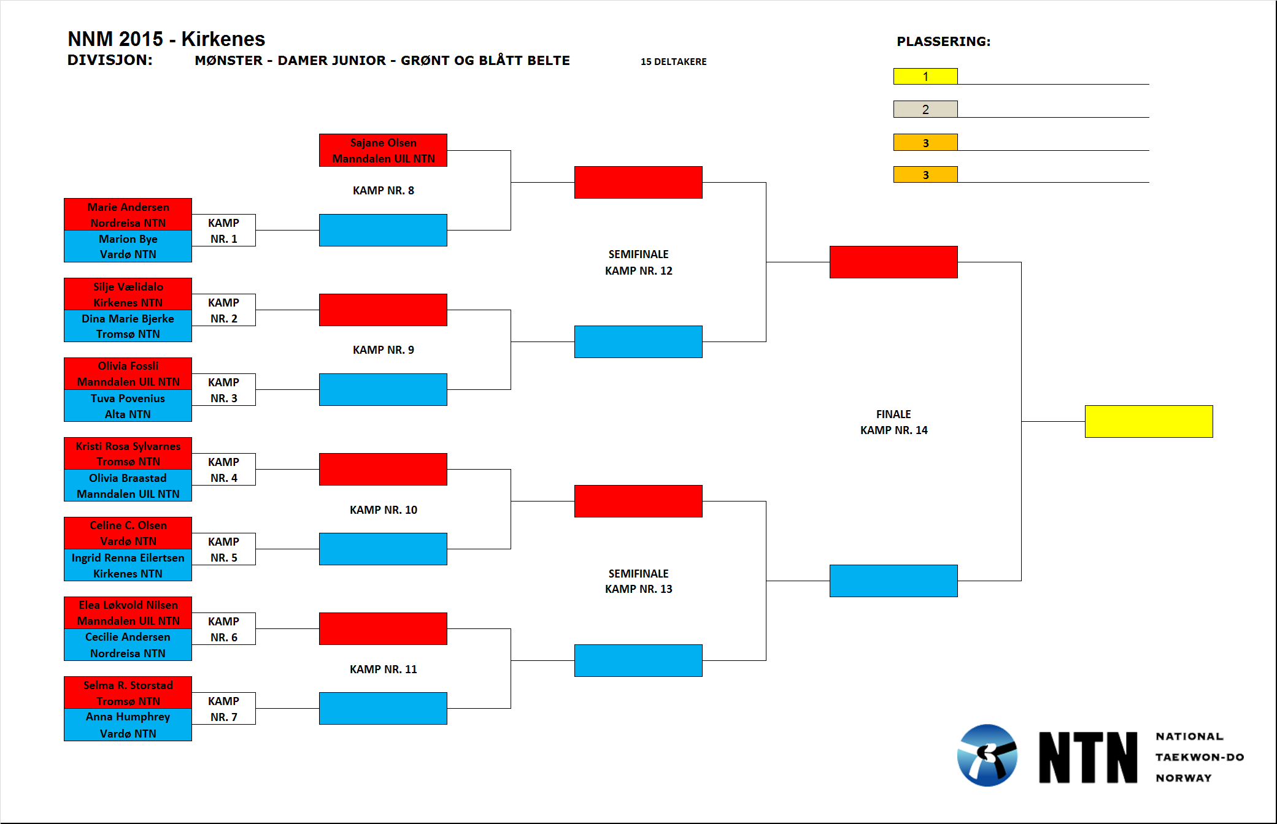

**Divisjon:** Mønster – damer eldre junior – sort belte – **6 deltakere**

|  |  |  |  |  |  |  |  |  |
| --- | --- | --- | --- | --- | --- | --- | --- | --- |
| **Pool A** | | | | | | | | |
|  | **Navn** | **Klubb** | **1** | **2** | **3** | **Seire** | **Poeng** | **Plass** |
| **1** | Solveig Larsen Aas | Tromsø NTN |  |  |  |  |  |  |
| **2** | Karina Skagen Enoksen | Kirkenes NTN |  |  |  |  |  |  |
| **3** | Frida Abelsen | Salten NTN |  |  |  |  |  |  |

|  |  |  |  |  |  |  |
| --- | --- | --- | --- | --- | --- | --- |
| **Kamp nr.** | **1** | | **3** | | **5** | |
| **Rød | Blå** | **1** | **2** | **2** | **3** | **1** | **3** |
| **Resutat** |  | |  | |  | |

|  |  |  |  |  |  |  |  |  |
| --- | --- | --- | --- | --- | --- | --- | --- | --- |
| **Pool B** | | | | | | | | |
|  | **Navn** | **Klubb** | **1** | **2** | **3** | **Seire** | **Poeng** | **Plass** |
| **1** | Mai-Linn Johannessen | Alta NTN |  |  |  |  |  |  |
| **2** | Frida Lyngedal Tøllefsen | Tromsø NTN |  |  |  |  |  |  |
| **3** | Ronja Persen | Kirkenes NTN |  |  |  |  |  |  |

|  |  |  |  |  |  |  |
| --- | --- | --- | --- | --- | --- | --- |
| **Kamp nr.** | **2** | | **4** | | **6** | |
| **Rød | Blå** | **1** | **2** | **2** | **3** | **1** | **3** |
| **Resutat** |  | |  | |  | |

|  |  |  |  |  |  |  |
| --- | --- | --- | --- | --- | --- | --- |
| **Semifinale 1** | |  |  |  | |  |
| **7** | **A1:** |  |  |  | |  |
| **B2:** |  |  | **Finale** | |
|  |  |  |  | **9** |  |
|  |  |  |  |  |
| **Semifinale 2** | |  |  |  |  |
| **8** | **A2:** |  |  |  |  |
| **B1:** |  |  |  |  |

|  |  |
| --- | --- |
| **Resultat** | |
| **1** |  |
| **2** |  |
| **3** |  |
| **3** |  |

**Divisjon:** Mønster – damer eldre junior – fargede belter – **3 deltakere**

|  |  |  |
| --- | --- | --- |
|  | **Navn** | **Klubb** |
| **A** | Karianne Svingen Asphaug | Målselv NTN |
| **B** | Edel Sofie Thomassen | Alta NTN |
| **C** | Therese Eikrem Frekhaug | Tromsø NTN |

**Kamp nr. 1:**

A (rød) vs. B (blå)

**Kamp nr. 2:**

Vinneren av kamp nr. 1 (rød) møter C (blå).

**Kamp 3 (kun dersom C vinner):**

Taperen av kamp nr. 1 (rød) møter taperen av kamp nr. 2 (rød)

|  |  |
| --- | --- |
| **Resultat** | |
| **1** |  |
| **2** |  |

**Divisjon:** Mønster – damer senior – sort belte – **3 deltakere**

|  |  |  |  |  |  |  |  |  |
| --- | --- | --- | --- | --- | --- | --- | --- | --- |
| **Pool A** | | | | | | | | |
|  | **Navn** | **Klubb** | **1** | **2** | **3** | **Seire** | **Poeng** | **Plass** |
| **1** | Elise Bye | Salten NTN |  |  |  |  |  |  |
| **2** | Kaja Turner | Kirkenes NTN |  |  |  |  |  |  |
| **3** | Marte Brasøy Sætrum | Vardø NTN |  |  |  |  |  |  |

**Kamp nr. 1:**

A (rød) vs. B (blå)

**Kamp nr. 2:**

Vinneren av kamp nr. 1 (rød) møter C (blå).

**Kamp 3 (kun dersom C vinner):**

Taperen av kamp nr. 1 (rød) møter taperen av kamp nr. 2 (rød)

|  |  |
| --- | --- |
| **Resultat** | |
| **1** |  |
| **2** |  |

**Divisjon:** Mønster – damer senior – fargede belter – **3 deltakere**

|  |  |  |  |  |  |  |  |  |
| --- | --- | --- | --- | --- | --- | --- | --- | --- |
| **Pool A** | | | | | | | | |
|  | **Navn** | **Klubb** | **1** | **2** | **3** | **Seire** | **Poeng** | **Plass** |
| **1** | Lisa Mari Heitmann | Alta NTN |  |  |  |  |  |  |
| **2** | Elise Simpson | Målselv NTN |  |  |  |  |  |  |
| **3** | Viktorija Koblova | Båtsfjord NTN |  |  |  |  |  |  |

**Kamp nr. 1:**

A (rød) vs. B (blå)

**Kamp nr. 2:**

Vinneren av kamp nr. 1 (rød) møter C (blå).

**Kamp 3 (kun dersom C vinner):**

Taperen av kamp nr. 1 (rød) møter taperen av kamp nr. 2 (rød)

|  |  |
| --- | --- |
| **Resultat** | |
| **1** |  |
| **2** |  |

**Divisjon:** Mønster – damer veteran – åpen klasse – **4 deltakere**

|  |  |  |  |  |  |  |  |  |  |
| --- | --- | --- | --- | --- | --- | --- | --- | --- | --- |
| **Pool A** | | | | | | | | | |
|  | **Navn** | **Klubb** | **1** | **2** | **3** | **4** | **Seire** | **Poeng** | **Plass** |
| **1** | Eija Välikangas | Kirkenes NTN |  |  |  |  |  |  |  |
| **2** | Lena Warelius | Kirkenes NTN |  |  |  |  |  |  |  |
| **3** | Lill Tove Erikstad | Kirkenes NTN |  |  |  |  |  |  |  |
| **4** | Janne Kolpus | Kirkenes NTN |  |  |  |  |  |  |  |

|  |  |  |  |  |  |  |  |  |  |  |  |  |
| --- | --- | --- | --- | --- | --- | --- | --- | --- | --- | --- | --- | --- |
| **Kamp nr.** | **1** | | **2** | | **3** | | **4** | | **5** | | **6** | |
| **Rød | Blå** | **1** | **2** | **3** | **4** | **2** | **3** | **1** | **4** | **1** | **3** | **2** | **4** |
| **Resutat** |  | |  | |  | |  | |  | |  | |

|  |  |
| --- | --- |
| **Resultat** | |
| **1** |  |
| **2** |  |
| **3** |  |

**Divisjon:** Mønster – herrer yngre junior – åpen klasse – **6 deltakere**

|  |  |  |  |  |  |  |  |  |
| --- | --- | --- | --- | --- | --- | --- | --- | --- |
| **Pool A** | | | | | | | | |
|  | **Navn** | **Klubb** | **1** | **2** | **3** | **Seire** | **Poeng** | **Plass** |
| **1** | Tomm Haugen | Setermoen NTN |  |  |  |  |  |  |
| **2** | Eivind Dalhaug | Kirkenes NTN |  |  |  |  |  |  |
| **3** | Rene Persen | Kjøllefjord NTN |  |  |  |  |  |  |

|  |  |  |  |  |  |  |
| --- | --- | --- | --- | --- | --- | --- |
| **Kamp nr.** | **1** | | **3** | | **5** | |
| **Rød | Blå** | **1** | **2** | **2** | **3** | **1** | **3** |
| **Resutat** |  | |  | |  | |

|  |  |  |  |  |  |  |  |  |
| --- | --- | --- | --- | --- | --- | --- | --- | --- |
| **Pool B** | | | | | | | | |
|  | **Navn** | **Klubb** | **1** | **2** | **3** | **Seire** | **Poeng** | **Plass** |
| **1** | Adrian Lind | Setermoen NTN |  |  |  |  |  |  |
| **2** | Chris Jensen | Tromsø NTN |  |  |  |  |  |  |
| **3** | Iver Henninen | Kirkenes NTN |  |  |  |  |  |  |

|  |  |  |  |  |  |  |
| --- | --- | --- | --- | --- | --- | --- |
| **Kamp nr.** | **2** | | **4** | | **6** | |
| **Rød | Blå** | **1** | **2** | **2** | **3** | **1** | **3** |
| **Resutat** |  | |  | |  | |

|  |  |  |  |  |  |  |
| --- | --- | --- | --- | --- | --- | --- |
| **Semifinale 1** | |  |  |  | |  |
| **7** | **A1:** |  |  |  | |  |
| **B2:** |  |  | **Finale** | |
|  |  |  |  | **9** |  |
|  |  |  |  |  |
| **Semifinale 2** | |  |  |  |  |
| **8** | **A2:** |  |  |  |  |
| **B1:** |  |  |  |  |

|  |  |
| --- | --- |
| **Resultat** | |
| **1** |  |
| **2** |  |
| **3** |  |
| **3** |  |

**Divisjon:** Mønster – herrer junior – rødt belte – **9 deltakere**

|  |  |  |  |  |  |  |  |  |  |  |
| --- | --- | --- | --- | --- | --- | --- | --- | --- | --- | --- |
| **Pool A** | | | | | | | | | | |
|  | **Navn** | **Klubb** | **1** | **2** | **3** | **4** | **5** | **Seire** | **Poeng** | **Plass** |
| **1** | Elling Nymo Johnsen | Lakselv NTN |  |  |  |  |  |  |  |  |
| **2** | Ådne Nilsen | Setermoen NTN |  |  |  |  |  |  |  |  |
| **3** | Rasmus Andreassen | Målselv NTN |  |  |  |  |  |  |  |  |
| **4** | Marius Radem | Alta NTN |  |  |  |  |  |  |  |  |
| **5** | Mathias Kristiansen | Lakselv NTN |  |  |  |  |  |  |  |  |

|  |  |  |  |  |  |  |  |  |  |  |  |  |  |  |  |  |  |  |  |  |
| --- | --- | --- | --- | --- | --- | --- | --- | --- | --- | --- | --- | --- | --- | --- | --- | --- | --- | --- | --- | --- |
| **Kamp nr.** | **1** | | **2** | | **5** | | **6** | | **9** | | **10** | | **13** | | **14** | | **15** | | **16** | |
| **Rød | Blå** | **4** | **5** | **1** | **2** | **3** | **4** | **1** | **5** | **2** | **3** | **1** | **4** | **2** | **5** | **1** | **3** | **2** | **4** | **3** | **5** |
| **Resutat** |  | |  | |  | |  | |  | |  | |  | |  | |  | |  | |

|  |  |  |  |  |  |  |  |  |  |
| --- | --- | --- | --- | --- | --- | --- | --- | --- | --- |
| **Pool B** | | | | | | | | | |
|  | **Navn** | **Klubb** | **1** | **2** | **3** | **4** | **Seire** | **Poeng** | **Plass** |
| **1** | Thomas Kåven | Lakselv NTN |  |  |  |  |  |  |  |
| **2** | Kevin Halvorsen | Salten NTN |  |  |  |  |  |  |  |
| **3** | Håvar Pedersen | Kirkenes NTN |  |  |  |  |  |  |  |
| **4** | Simon Tråsdahl Sønnerheim | Målselv NTN |  |  |  |  |  |  |  |

|  |  |  |  |  |  |  |  |  |  |  |  |  |
| --- | --- | --- | --- | --- | --- | --- | --- | --- | --- | --- | --- | --- |
| **Kamp nr.** | **3** | | **4** | | **7** | | **8** | | **11** | | **12** | |
| **Rød | Blå** | **1** | **2** | **3** | **4** | **2** | **3** | **1** | **4** | **1** | **3** | **2** | **4** |
| **Resutat** |  | |  | |  | |  | |  | |  | |

|  |  |  |  |  |  |  |
| --- | --- | --- | --- | --- | --- | --- |
| **Semifinale 1** | |  |  |  | |  |
| **17** | **A1:** |  |  |  | |  |
| **B2:** |  |  | **Finale** | |
|  |  |  |  | **19** |  |
|  |  |  |  |  |
| **Semifinale 2** | |  |  |  |  |
| **18** | **A2:** |  |  |  |  |
| **B1:** |  |  |  |  |

|  |  |
| --- | --- |
| **Resultat** | |
| **1** |  |
| **2** |  |
| **3** |  |
| **3** |  |

**Divisjon:** Mønster – herrer junior – grønt og blått belte – **4 deltakere**

|  |  |  |  |  |  |  |  |  |  |
| --- | --- | --- | --- | --- | --- | --- | --- | --- | --- |
| **Pool A** | | | | | | | | | |
|  | **Navn** | **Klubb** | **1** | **2** | **3** | **4** | **Seire** | **Poeng** | **Plass** |
| **1** | Sivert Lyngstad | Alta NTN |  |  |  |  |  |  |  |
| **2** | Fredric Roman | Setermoen NTN |  |  |  |  |  |  |  |
| **3** | Esben Ringbu Jensen | Alta NTN |  |  |  |  |  |  |  |
| **4** | Petter Nilsen | Alta NTN |  |  |  |  |  |  |  |

|  |  |  |  |  |  |  |  |  |  |  |  |  |
| --- | --- | --- | --- | --- | --- | --- | --- | --- | --- | --- | --- | --- |
| **Kamp nr.** | **1** | | **2** | | **3** | | **4** | | **5** | | **6** | |
| **Rød | Blå** | **1** | **2** | **3** | **4** | **2** | **3** | **1** | **4** | **1** | **3** | **2** | **4** |
| **Resutat** |  | |  | |  | |  | |  | |  | |

|  |  |
| --- | --- |
| **Resultat** | |
| **1** |  |
| **2** |  |
| **3** |  |

**Divisjon:** Mønster – herrer eldre junior – sort belte – **6 deltakere**

|  |  |  |  |  |  |  |  |  |
| --- | --- | --- | --- | --- | --- | --- | --- | --- |
| **Pool A** | | | | | | | | |
|  | **Navn** | **Klubb** | **1** | **2** | **3** | **Seire** | **Poeng** | **Plass** |
| **1** | Inge Løvøy Hegge | Lakselv NTN |  |  |  |  |  |  |
| **2** | Ulrik Sundquist | Kirkenes NTN |  |  |  |  |  |  |
| **3** | Sander Solhaug | ATN Tromsø |  |  |  |  |  |  |

|  |  |  |  |  |  |  |
| --- | --- | --- | --- | --- | --- | --- |
| **Kamp nr.** | **1** | | **3** | | **5** | |
| **Rød | Blå** | **1** | **2** | **2** | **3** | **1** | **3** |
| **Resutat** |  | |  | |  | |

|  |  |  |  |  |  |  |  |  |
| --- | --- | --- | --- | --- | --- | --- | --- | --- |
| **Pool B** | | | | | | | | |
|  | **Navn** | **Klubb** | **1** | **2** | **3** | **Seire** | **Poeng** | **Plass** |
| **1** | Iver Kjellmo Johansen | Kirkenes NTN |  |  |  |  |  |  |
| **2** | Andreas Søraa Moe | Alta NTN |  |  |  |  |  |  |
| **3** | Lars-Herman Nordland | Salten NTN |  |  |  |  |  |  |

|  |  |  |  |  |  |  |
| --- | --- | --- | --- | --- | --- | --- |
| **Kamp nr.** | **2** | | **4** | | **6** | |
| **Rød | Blå** | **1** | **2** | **2** | **3** | **1** | **3** |
| **Resutat** |  | |  | |  | |

|  |  |  |  |  |  |  |
| --- | --- | --- | --- | --- | --- | --- |
| **Semifinale 1** | |  |  |  | |  |
| **7** | **A1:** |  |  |  | |  |
| **B2:** |  |  | **Finale** | |
|  |  |  |  | **9** |  |
|  |  |  |  |  |
| **Semifinale 2** | |  |  |  |  |
| **8** | **A2:** |  |  |  |  |
| **B1:** |  |  |  |  |

|  |  |
| --- | --- |
| **Resultat** | |
| **1** |  |
| **2** |  |
| **3** |  |
| **3** |  |

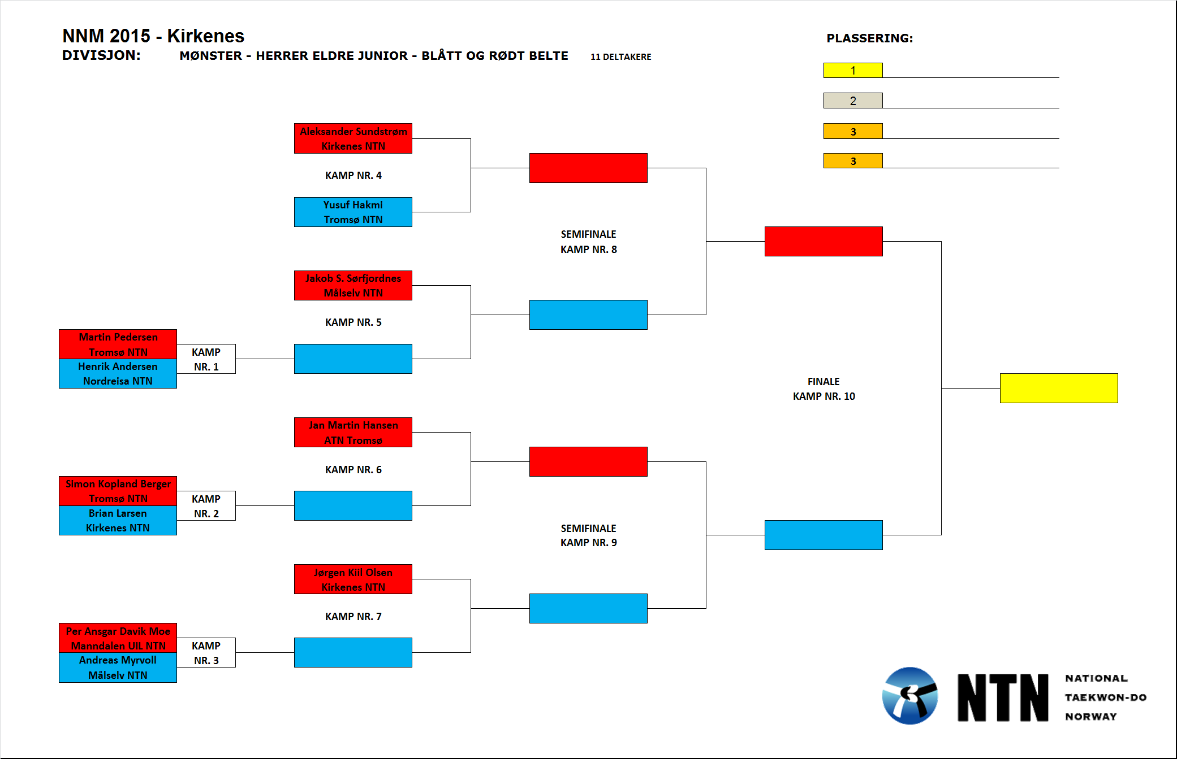

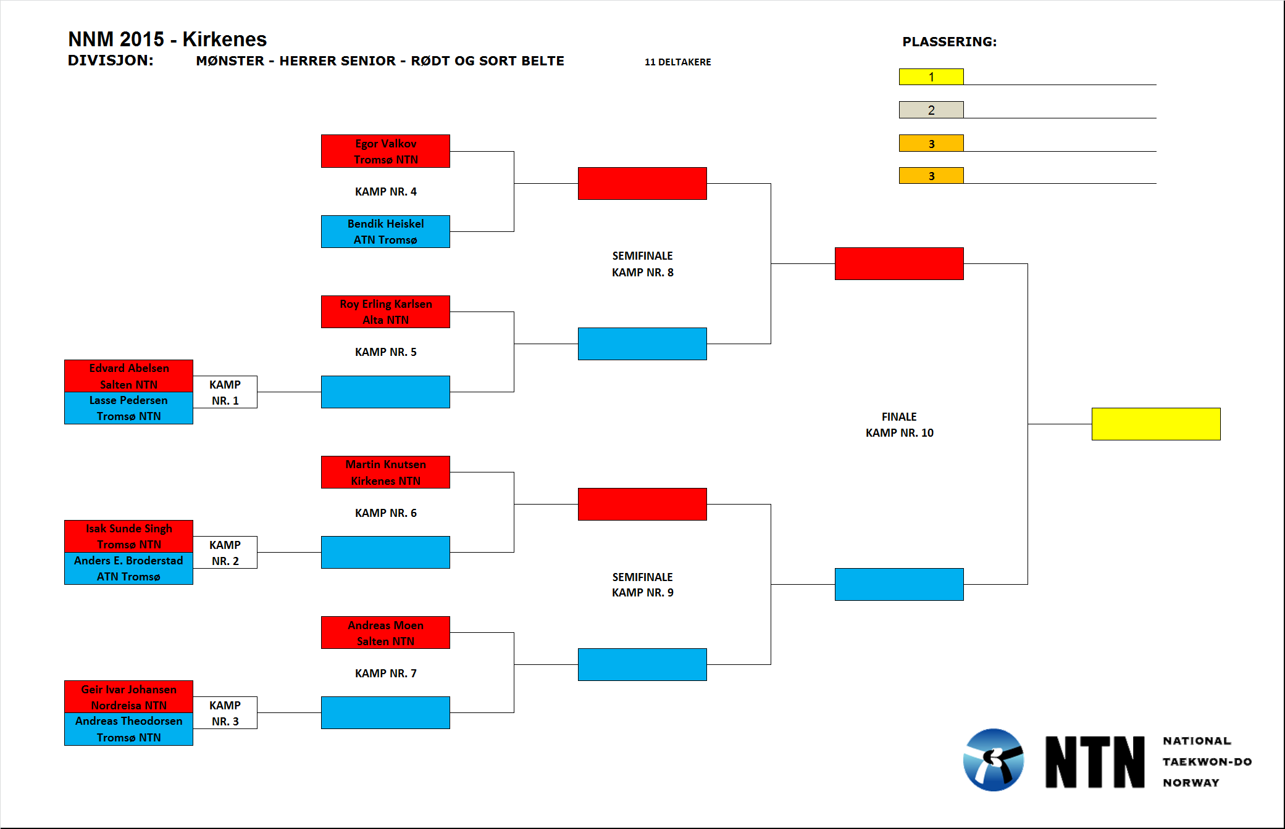

**Divisjon:** Mønster – herrer veteran – sort belte – **4 deltakere**

|  |  |  |  |  |  |  |  |  |  |
| --- | --- | --- | --- | --- | --- | --- | --- | --- | --- |
| **Pool A** | | | | | | | | | |
|  | **Navn** | **Klubb** | **1** | **2** | **3** | **4** | **Seire** | **Poeng** | **Plass** |
| **1** | Trond Nordland | Salten NTN |  |  |  |  |  |  |  |
| **2** | Tor-Gunnar Tro Johnsen | Kirkenes NTN |  |  |  |  |  |  |  |
| **3** | Ole Christian Povenius | Alta NTN |  |  |  |  |  |  |  |
| **4** | Rune Bye | Salten NTN |  |  |  |  |  |  |  |

|  |  |  |  |  |  |  |  |  |  |  |  |  |
| --- | --- | --- | --- | --- | --- | --- | --- | --- | --- | --- | --- | --- |
| **Kamp nr.** | **1** | | **2** | | **3** | | **4** | | **5** | | **6** | |
| **Rød | Blå** | **1** | **2** | **3** | **4** | **2** | **3** | **1** | **4** | **1** | **3** | **2** | **4** |
| **Resutat** |  | |  | |  | |  | |  | |  | |

|  |  |
| --- | --- |
| **Resultat** | |
| **1** |  |
| **2** |  |
| **3** |  |

**Divisjon:** Mønster – herrer veteran – fargede belter – **10 deltakere**

|  |  |  |  |  |  |  |  |  |  |  |
| --- | --- | --- | --- | --- | --- | --- | --- | --- | --- | --- |
| **Pool A** | | | | | | | | | | |
|  | **Navn** | **Klubb** | **1** | **2** | **3** | **4** | **5** | **Seire** | **Poeng** | **Plass** |
| **1** | Geir Carlsen | Alta NTN |  |  |  |  |  |  |  |  |
| **2** | Øyvind Friskilæ | Kirkenes NTN |  |  |  |  |  |  |  |  |
| **3** | Kristian Didriksen | Lakselv NTN |  |  |  |  |  |  |  |  |
| **4** | Geir Ottesen | Båtsfjord NTN |  |  |  |  |  |  |  |  |
| **5** | Cato Radem | Alta NTN |  |  |  |  |  |  |  |  |

|  |  |  |  |  |  |  |  |  |  |  |  |  |  |  |  |  |  |  |  |  |
| --- | --- | --- | --- | --- | --- | --- | --- | --- | --- | --- | --- | --- | --- | --- | --- | --- | --- | --- | --- | --- |
| **Kamp nr.** | **1** | | **2** | | **5** | | **6** | | **9** | | **10** | | **13** | | **14** | | **17** | | **18** | |
| **Rød | Blå** | **4** | **5** | **1** | **2** | **3** | **4** | **1** | **5** | **2** | **3** | **1** | **4** | **2** | **5** | **1** | **3** | **2** | **4** | **3** | **5** |
| **Resutat** |  | |  | |  | |  | |  | |  | |  | |  | |  | |  | |

|  |  |  |  |  |  |  |  |  |  |  |
| --- | --- | --- | --- | --- | --- | --- | --- | --- | --- | --- |
| **Pool B** | | | | | | | | | | |
|  | **Navn** | **Klubb** | **1** | **2** | **3** | **4** | **5** | **Seire** | **Poeng** | **Plass** |
| **1** | Tore Gundersen | Alta NTN |  |  |  |  |  |  |  |  |
| **2** | Jørn Eirik Pedersen | Kirkenes NTN |  |  |  |  |  |  |  |  |
| **3** | Stig Rune Nergaard | Båtsfjord NTN |  |  |  |  |  |  |  |  |
| **4** | Rune Solhaug | ATN Tromsø |  |  |  |  |  |  |  |  |
| **5** | Stian Elverum | Vardø NTN |  |  |  |  |  |  |  |  |

|  |  |  |  |  |  |  |  |  |  |  |  |  |  |  |  |  |  |  |  |  |
| --- | --- | --- | --- | --- | --- | --- | --- | --- | --- | --- | --- | --- | --- | --- | --- | --- | --- | --- | --- | --- |
| **Kamp nr.** | **3** | | **4** | | **7** | | **8** | | **11** | | **12** | | **15** | | **16** | | **19** | | **20** | |
| **Rød | Blå** | **4** | **5** | **1** | **2** | **3** | **4** | **1** | **5** | **2** | **3** | **1** | **4** | **2** | **5** | **1** | **3** | **2** | **4** | **3** | **5** |
| **Resutat** |  | |  | |  | |  | |  | |  | |  | |  | |  | |  | |

|  |  |  |  |  |  |  |
| --- | --- | --- | --- | --- | --- | --- |
| **Semifinale 1** | |  |  |  | |  |
| **21** | **A1:** |  |  |  | |  |
| **B2:** |  |  | **Finale** | |
|  |  |  |  | **23** |  |
|  |  |  |  |  |
| **Semifinale 2** | |  |  |  |  |
| **22** | **A2:** |  |  |  |  |
| **B1:** |  |  |  |  |

|  |  |
| --- | --- |
| **Resultat** | |
| **1** |  |
| **2** |  |
| **3** |  |
| **3** |  |

**Divisjon:** Sparring – damer yngre junior: +155 cm – **2 deltakere**

|  |  |  |  |  |  |
| --- | --- | --- | --- | --- | --- |
| **Mina Bratterud** | |  |  |  |  |
| **ATN Tromsø** | |  |  |  |  |
|  |  |  |  |  |  |
| **KAMP NR. 1** | |  |  |  |  |
|  |  |  |  |  |  |
| **Ragna Knoff** | |  |  |  |  |
| **ATN Tromsø** | |  |  |  |  |

|  |  |
| --- | --- |
| **Resultat** | |
| **1** |  |

**Divisjon:** Mønster – damer yngre junior: -155 cm – **5 deltakere**

|  |  |  |  |  |  |  |  |  |  |  |
| --- | --- | --- | --- | --- | --- | --- | --- | --- | --- | --- |
| **Pool A** | | | | | | | | | | |
|  | **Navn** | **Klubb** | **1** | **2** | **3** | **4** | **5** | **Seire** | **Poeng** | **Plass** |
| **1** | Adelen Fjelde | Vardø NTN |  |  |  |  |  |  |  |  |
| **2** | Martine Solhaug | ATN Tromsø |  |  |  |  |  |  |  |  |
| **3** | Tuva Valvatne | Kirkenes NTN |  |  |  |  |  |  |  |  |
| **4** | Helle Schrøder Leiros | Tromsø NTN |  |  |  |  |  |  |  |  |
| **5** | Celine Wilhelmsen | Vardø NTN |  |  |  |  |  |  |  |  |

|  |  |  |  |  |  |  |  |  |  |  |  |  |  |  |  |  |  |  |  |  |
| --- | --- | --- | --- | --- | --- | --- | --- | --- | --- | --- | --- | --- | --- | --- | --- | --- | --- | --- | --- | --- |
| **Kamp nr.** | **1** | | **2** | | **3** | | **4** | | **5** | | **6** | | **7** | | **8** | | **9** | | **10** | |
| **Rød | Blå** | **4** | **5** | **1** | **2** | **3** | **4** | **1** | **5** | **2** | **3** | **1** | **4** | **2** | **5** | **1** | **3** | **2** | **4** | **3** | **5** |
| **Resutat** |  | |  | |  | |  | |  | |  | |  | |  | |  | |  | |

|  |  |
| --- | --- |
| **Resultat** | |
| **1** |  |
| **2** |  |
| **3** |  |

**Divisjon:** Sparring – damer junior: +60 kg – **7 deltakere**

|  |  |  |  |  |  |  |  |  |  |
| --- | --- | --- | --- | --- | --- | --- | --- | --- | --- |
| **Pool A** | | | | | | | | | |
|  | **Navn** | **Klubb** | **1** | **2** | **3** | **4** | **Seire** | **Poeng** | **Plass** |
| **1** | Cecilie Andersen | Nordreisa NTN |  |  |  |  |  |  |  |
| **2** | Julie Sundstrøm | Kirkenes NTN |  |  |  |  |  |  |  |
| **3** | Embla Olsen | ATN Tromsø |  |  |  |  |  |  |  |
| **4** | Mathilde Andersson | Alta NTN |  |  |  |  |  |  |  |

|  |  |  |  |  |  |  |  |  |  |  |  |  |
| --- | --- | --- | --- | --- | --- | --- | --- | --- | --- | --- | --- | --- |
| **Kamp nr.** | **1** | | **2** | | **3** | | **7** | | **8** | | **9** | |
| **Rød | Blå** | **1** | **2** | **3** | **4** | **2** | **3** | **1** | **4** | **1** | **3** | **2** | **4** |
| **Resutat** |  | |  | |  | |  | |  | |  | |

|  |  |  |  |  |  |  |  |  |
| --- | --- | --- | --- | --- | --- | --- | --- | --- |
| **Pool B** | | | | | | | | |
|  | **Navn** | **Klubb** | **1** | **2** | **3** | **Seire** | **Poeng** | **Plass** |
| **1** | Marion Bye | Vardø NTN |  |  |  |  |  |  |
| **2** | Elisabeth Nordgaard | Tromsø NTN |  |  |  |  |  |  |
| **3** | Marie Andersen | Nordreisa NTN |  |  |  |  |  |  |

|  |  |  |  |  |  |  |
| --- | --- | --- | --- | --- | --- | --- |
| **Kamp nr.** | **4** | | **5** | | **6** | |
| **Rød | Blå** | **1** | **2** | **2** | **3** | **1** | **3** |
| **Resutat** |  | |  | |  | |

|  |  |  |  |  |  |  |
| --- | --- | --- | --- | --- | --- | --- |
| **Semifinale 1** | |  |  |  | |  |
| **10** | **A1:** |  |  |  | |  |
| **B2:** |  |  | **Finale** | |
|  |  |  |  | **12** |  |
|  |  |  |  |  |
| **Semifinale 2** | |  |  |  |  |
| **11** | **A2:** |  |  |  |  |
| **B1:** |  |  |  |  |

|  |  |
| --- | --- |
| **Resultat** | |
| **1** |  |
| **2** |  |
| **3** |  |
| **3** |  |

**Divisjon:** Sparring – damer junior: -60 kg – **5 deltakere**

|  |  |  |  |  |  |  |  |  |  |  |
| --- | --- | --- | --- | --- | --- | --- | --- | --- | --- | --- |
| **Pool A** | | | | | | | | | | |
|  | **Navn** | **Klubb** | **1** | **2** | **3** | **4** | **5** | **Seire** | **Poeng** | **Plass** |
| **1** | Silje Vælidalo | Kirkenes NTN |  |  |  |  |  |  |  |  |
| **2** | Tuva Povenius | Alta NTN |  |  |  |  |  |  |  |  |
| **3** | Dina Marie Bjerke | Tromsø NTN |  |  |  |  |  |  |  |  |
| **4** | Ingrid Renna Eilertsen | Kirkenes NTN |  |  |  |  |  |  |  |  |
| **5** | Ingrid Helena Hansen | ATN Tromsø |  |  |  |  |  |  |  |  |

|  |  |  |  |  |  |  |  |  |  |  |  |  |  |  |  |  |  |  |  |  |
| --- | --- | --- | --- | --- | --- | --- | --- | --- | --- | --- | --- | --- | --- | --- | --- | --- | --- | --- | --- | --- |
| **Kamp nr.** | **1** | | **2** | | **3** | | **4** | | **5** | | **6** | | **7** | | **8** | | **9** | | **10** | |
| **Rød | Blå** | **4** | **5** | **1** | **2** | **3** | **4** | **1** | **5** | **2** | **3** | **1** | **4** | **2** | **5** | **1** | **3** | **2** | **4** | **3** | **5** |
| **Resutat** |  | |  | |  | |  | |  | |  | |  | |  | |  | |  | |

|  |  |
| --- | --- |
| **Resultat** | |
| **1** |  |
| **2** |  |
| **3** |  |

**Divisjon:** Sparring – damer junior: -50 kg – **7 deltakere**

|  |  |  |  |  |  |  |  |  |  |
| --- | --- | --- | --- | --- | --- | --- | --- | --- | --- |
| **Pool A** | | | | | | | | | |
|  | **Navn** | **Klubb** | **1** | **2** | **3** | **4** | **Seire** | **Poeng** | **Plass** |
| **1** | Sajane Olsen | Manndalen UIL NTN |  |  |  |  |  |  |  |
| **2** | Anna Humphrey | Vardø NTN |  |  |  |  |  |  |  |
| **3** | Olivia Fossli | Manndalen UIL NTN |  |  |  |  |  |  |  |
| **4** | Selma Storstad | Tromsø NTN |  |  |  |  |  |  |  |

|  |  |  |  |  |  |  |  |  |  |  |  |  |
| --- | --- | --- | --- | --- | --- | --- | --- | --- | --- | --- | --- | --- |
| **Kamp nr.** | **1** | | **2** | | **3** | | **7** | | **8** | | **9** | |
| **Rød | Blå** | **1** | **2** | **3** | **4** | **2** | **3** | **1** | **4** | **1** | **3** | **2** | **4** |
| **Resutat** |  | |  | |  | |  | |  | |  | |

|  |  |  |  |  |  |  |  |  |
| --- | --- | --- | --- | --- | --- | --- | --- | --- |
| **Pool B** | | | | | | | | |
|  | **Navn** | **Klubb** | **1** | **2** | **3** | **Seire** | **Poeng** | **Plass** |
| **1** | Kristi Rosa Sylvarnes | Tromsø NTN |  |  |  |  |  |  |
| **2** | Olivia Braastad | Manndalen UIL NTN |  |  |  |  |  |  |
| **3** | Celine Christensen Olsen | Vardø NTN |  |  |  |  |  |  |

|  |  |  |  |  |  |  |
| --- | --- | --- | --- | --- | --- | --- |
| **Kamp nr.** | **4** | | **5** | | **6** | |
| **Rød | Blå** | **1** | **2** | **2** | **3** | **1** | **3** |
| **Resutat** |  | |  | |  | |

|  |  |  |  |  |  |  |
| --- | --- | --- | --- | --- | --- | --- |
| **Semifinale 1** | |  |  |  | |  |
| **10** | **A1:** |  |  |  | |  |
| **B2:** |  |  | **Finale** | |
|  |  |  |  | **12** |  |
|  |  |  |  |  |
| **Semifinale 2** | |  |  |  |  |
| **11** | **A2:** |  |  |  |  |
| **B1:** |  |  |  |  |

|  |  |
| --- | --- |
| **Resultat** | |
| **1** |  |
| **2** |  |
| **3** |  |
| **3** |  |

**Divisjon:** Sparring – damer eldre junior: +60 kg **– 4 deltakere**

|  |  |  |  |  |  |  |  |  |  |
| --- | --- | --- | --- | --- | --- | --- | --- | --- | --- |
| **Pool A** | | | | | | | | | |
|  | **Navn** | **Klubb** | **1** | **2** | **3** | **4** | **Seire** | **Poeng** | **Plass** |
| **1** | Edel Sofie Thomassen | Alta NTN |  |  |  |  |  |  |  |
| **2** | Therese Eikrem Frekhaug | Tromsø NTN |  |  |  |  |  |  |  |
| **3** | Karianne Svingen Asphaug | Målselv NTN |  |  |  |  |  |  |  |
| **4** | Frida Abelsen | Salten NTN |  |  |  |  |  |  |  |

|  |  |  |  |  |  |  |  |  |  |  |  |  |
| --- | --- | --- | --- | --- | --- | --- | --- | --- | --- | --- | --- | --- |
| **Kamp nr.** | **1** | | **2** | | **3** | | **4** | | **5** | | **6** | |
| **Rød | Blå** | **1** | **2** | **3** | **4** | **2** | **3** | **1** | **4** | **1** | **3** | **2** | **4** |
| **Resutat** |  | |  | |  | |  | |  | |  | |

|  |  |
| --- | --- |
| **Resultat** | |
| **1** |  |
| **2** |  |
| **3** |  |

**Divisjon:** Sparring – damer eldre junior: -60 kg – **4 deltakere**

|  |  |  |  |  |  |  |  |  |  |
| --- | --- | --- | --- | --- | --- | --- | --- | --- | --- |
| **Pool A** | | | | | | | | | |
|  | **Navn** | **Klubb** | **1** | **2** | **3** | **4** | **Seire** | **Poeng** | **Plass** |
| **1** | Karina Skagen Enoksen | Kirkenes NTN |  |  |  |  |  |  |  |
| **2** | Solveig Larsen Aas | Tromsø NTN |  |  |  |  |  |  |  |
| **3** | Mai-Linn Johannessen | Alta NTN |  |  |  |  |  |  |  |
| **4** | Ronja Persen | Kirkenes NTN |  |  |  |  |  |  |  |

|  |  |  |  |  |  |  |  |  |  |  |  |  |
| --- | --- | --- | --- | --- | --- | --- | --- | --- | --- | --- | --- | --- |
| **Kamp nr.** | **1** | | **2** | | **3** | | **4** | | **5** | | **6** | |
| **Rød | Blå** | **1** | **2** | **3** | **4** | **2** | **3** | **1** | **4** | **1** | **3** | **2** | **4** |
| **Resutat** |  | |  | |  | |  | |  | |  | |

|  |  |
| --- | --- |
| **Resultat** | |
| **1** |  |
| **2** |  |
| **3** |  |

**Divisjon:** Sparring – damer senior – åpen klasse – **3 deltakere**

|  |  |  |  |  |  |  |  |  |
| --- | --- | --- | --- | --- | --- | --- | --- | --- |
| **Pool A** | | | | | | | | |
|  | **Navn** | **Klubb** | **1** | **2** | **3** | **Seire** | **Poeng** | **Plass** |
| **1** | Lisa Mari Heitmann | Alta NTN |  |  |  |  |  |  |
| **2** | Kaja Turner | Kirkenes NTN |  |  |  |  |  |  |
| **3** | Marte Brasøy Sætrum | Vardø NTN |  |  |  |  |  |  |

|  |  |  |  |  |  |  |
| --- | --- | --- | --- | --- | --- | --- |
| **Kamp nr.** | **1** | | **2** | | **3** | |
| **Rød | Blå** | **1** | **2** | **2** | **3** | **1** | **3** |
| **Resutat** |  | |  | |  | |

|  |  |
| --- | --- |
| **Resultat** | |
| **1** |  |
| **2** |  |

**Divisjon:** Sparring – damer veteran: åpen klasse – **4 deltakere**

|  |  |  |  |  |  |  |  |  |  |
| --- | --- | --- | --- | --- | --- | --- | --- | --- | --- |
| **Pool A** | | | | | | | | | |
|  | **Navn** | **Klubb** | **1** | **2** | **3** | **4** | **Seire** | **Poeng** | **Plass** |
| **1** | Janne Kolpus | Kirkenes NTN |  |  |  |  |  |  |  |
| **2** | Lena Warelius | Kirkenes NTN |  |  |  |  |  |  |  |
| **3** | Eija Välikangas | Kirkenes NTN |  |  |  |  |  |  |  |
| **4** | Lill Tove Erikstad | Kirkenes NTN |  |  |  |  |  |  |  |

|  |  |  |  |  |  |  |  |  |  |  |  |  |
| --- | --- | --- | --- | --- | --- | --- | --- | --- | --- | --- | --- | --- |
| **Kamp nr.** | **1** | | **2** | | **3** | | **4** | | **5** | | **6** | |
| **Rød | Blå** | **1** | **2** | **3** | **4** | **2** | **3** | **1** | **4** | **1** | **3** | **2** | **4** |
| **Resutat** |  | |  | |  | |  | |  | |  | |

|  |  |
| --- | --- |
| **Resultat** | |
| **1** |  |
| **2** |  |
| **3** |  |

**Divisjon:** Sparring – herrer yngre junior: åpen klasse – **4 deltakere**

|  |  |  |  |  |  |  |  |  |  |
| --- | --- | --- | --- | --- | --- | --- | --- | --- | --- |
| **Pool A** | | | | | | | | | |
|  | **Navn** | **Klubb** | **1** | **2** | **3** | **4** | **Seire** | **Poeng** | **Plass** |
| **1** | Eivind Dalhaug | Kirkenes NTN |  |  |  |  |  |  |  |
| **2** | Tomm Haugen | Setermoen NTN |  |  |  |  |  |  |  |
| **3** | Chris Jensen | Tromsø NTN |  |  |  |  |  |  |  |
| **4** | Iver Henninen | Kirkenes NTN |  |  |  |  |  |  |  |

|  |  |  |  |  |  |  |  |  |  |  |  |  |
| --- | --- | --- | --- | --- | --- | --- | --- | --- | --- | --- | --- | --- |
| **Kamp nr.** | **1** | | **2** | | **3** | | **4** | | **5** | | **6** | |
| **Rød | Blå** | **1** | **2** | **3** | **4** | **2** | **3** | **1** | **4** | **1** | **3** | **2** | **4** |
| **Resutat** |  | |  | |  | |  | |  | |  | |

|  |  |
| --- | --- |
| **Resultat** | |
| **1** |  |
| **2** |  |
| **3** |  |

**Divisjon:** Sparring – herrer junior: +68 kg **– 4 deltakere**

|  |  |  |  |  |  |  |  |  |  |
| --- | --- | --- | --- | --- | --- | --- | --- | --- | --- |
| **Pool A** | | | | | | | | | |
|  | **Navn** | **Klubb** | **1** | **2** | **3** | **4** | **Seire** | **Poeng** | **Plass** |
| **1** | Marius Radem | Alta NTN |  |  |  |  |  |  |  |
| **2** | Elling Nymo Johnsen | Lakselv NTN |  |  |  |  |  |  |  |
| **3** | Håvar Pedersen | Kirkenes NTN |  |  |  |  |  |  |  |
| **4** | Sivert Lyngstad | Alta NTN |  |  |  |  |  |  |  |

|  |  |  |  |  |  |  |  |  |  |  |  |  |
| --- | --- | --- | --- | --- | --- | --- | --- | --- | --- | --- | --- | --- |
| **Kamp nr.** | **1** | | **2** | | **3** | | **4** | | **5** | | **6** | |
| **Rød | Blå** | **1** | **2** | **3** | **4** | **2** | **3** | **1** | **4** | **1** | **3** | **2** | **4** |
| **Resutat** |  | |  | |  | |  | |  | |  | |

|  |  |
| --- | --- |
| **Resultat** | |
| **1** |  |
| **2** |  |
| **3** |  |

**Divisjon:** Sparring – herrer junior: -68 kg – **5 deltakere**

|  |  |  |  |  |  |  |  |  |  |  |
| --- | --- | --- | --- | --- | --- | --- | --- | --- | --- | --- |
| **Pool A** | | | | | | | | | | |
|  | **Navn** | **Klubb** | **1** | **2** | **3** | **4** | **5** | **Seire** | **Poeng** | **Plass** |
| **1** | Fredric Roman | Setermoen NTN |  |  |  |  |  |  |  |  |
| **2** | Petter Nilsen | Alta NTN |  |  |  |  |  |  |  |  |
| **3** | Rasmus Andreassen | Målselv NTN |  |  |  |  |  |  |  |  |
| **4** | Kevinn Halvorsen | Salten NTN |  |  |  |  |  |  |  |  |
| **5** | Ådne Nilsen | Setermoen NTN |  |  |  |  |  |  |  |  |

|  |  |  |  |  |  |  |  |  |  |  |  |  |  |  |  |  |  |  |  |  |
| --- | --- | --- | --- | --- | --- | --- | --- | --- | --- | --- | --- | --- | --- | --- | --- | --- | --- | --- | --- | --- |
| **Kamp nr.** | **1** | | **2** | | **3** | | **4** | | **5** | | **6** | | **7** | | **8** | | **9** | | **10** | |
| **Rød | Blå** | **4** | **5** | **1** | **2** | **3** | **4** | **1** | **5** | **2** | **3** | **1** | **4** | **2** | **5** | **1** | **3** | **2** | **4** | **3** | **5** |
| **Resutat** |  | |  | |  | |  | |  | |  | |  | |  | |  | |  | |

|  |  |
| --- | --- |
| **Resultat** | |
| **1** |  |
| **2** |  |
| **3** |  |

**Divisjon:** Sparring – herrer junior: -56 kg – **4 deltakere**

|  |  |  |  |  |  |  |  |  |  |
| --- | --- | --- | --- | --- | --- | --- | --- | --- | --- |
| **Pool A** | | | | | | | | | |
|  | **Navn** | **Klubb** | **1** | **2** | **3** | **4** | **Seire** | **Poeng** | **Plass** |
| **1** | Thomas Kåven | Lakselv NTN |  |  |  |  |  |  |  |
| **2** | Esben Ringbu Jensen | Alta NTN |  |  |  |  |  |  |  |
| **3** | Simon Tråsdahl Sønnerheim | Målselv NTN |  |  |  |  |  |  |  |
| **4** | Mathias Kristiansen | Lakselv NTN |  |  |  |  |  |  |  |

|  |  |  |  |  |  |  |  |  |  |  |  |  |
| --- | --- | --- | --- | --- | --- | --- | --- | --- | --- | --- | --- | --- |
| **Kamp nr.** | **1** | | **2** | | **3** | | **4** | | **5** | | **6** | |
| **Rød | Blå** | **1** | **2** | **3** | **4** | **2** | **3** | **1** | **4** | **1** | **3** | **2** | **4** |
| **Resutat** |  | |  | |  | |  | |  | |  | |

|  |  |
| --- | --- |
| **Resultat** | |
| **1** |  |
| **2** |  |
| **3** |  |

**Divisjon:** Sparring – herrer eldre junior: +75 kg – **5 deltakere**

|  |  |  |  |  |  |  |  |  |  |  |
| --- | --- | --- | --- | --- | --- | --- | --- | --- | --- | --- |
| **Pool A** | | | | | | | | | | |
|  | **Navn** | **Klubb** | **1** | **2** | **3** | **4** | **5** | **Seire** | **Poeng** | **Plass** |
| **1** | Jørgen Kiil Osen | Kirkenes NTN |  |  |  |  |  |  |  |  |
| **2** | Jakob Svendsen Sørfjordnes | Målselv NTN |  |  |  |  |  |  |  |  |
| **3** | Simon Kopland Berger | Tromsø NTN |  |  |  |  |  |  |  |  |
| **4** | Lars Magnar Nordal Hansen | Setermoen NTN |  |  |  |  |  |  |  |  |
| **5** | Iver Kjellmo Johansen | Kirkenes NTN |  |  |  |  |  |  |  |  |

|  |  |  |  |  |  |  |  |  |  |  |  |  |  |  |  |  |  |  |  |  |
| --- | --- | --- | --- | --- | --- | --- | --- | --- | --- | --- | --- | --- | --- | --- | --- | --- | --- | --- | --- | --- |
| **Kamp nr.** | **1** | | **2** | | **3** | | **4** | | **5** | | **6** | | **7** | | **8** | | **9** | | **10** | |
| **Rød | Blå** | **4** | **5** | **1** | **2** | **3** | **4** | **1** | **5** | **2** | **3** | **1** | **4** | **2** | **5** | **1** | **3** | **2** | **4** | **3** | **5** |
| **Resutat** |  | |  | |  | |  | |  | |  | |  | |  | |  | |  | |

|  |  |
| --- | --- |
| **Resultat** | |
| **1** |  |
| **2** |  |
| **3** |  |

**Divisjon:** Sparring – herrer eldre junior: -75 kg – **7 deltakere**

|  |  |  |  |  |  |  |  |  |  |
| --- | --- | --- | --- | --- | --- | --- | --- | --- | --- |
| **Pool A** | | | | | | | | | |
|  | **Navn** | **Klubb** | **1** | **2** | **3** | **4** | **Seire** | **Poeng** | **Plass** |
| **1** | Ulrik Sundquist | Kirkenes NTN |  |  |  |  |  |  |  |
| **2** | Yusuf Hakmi | Tromsø NTN |  |  |  |  |  |  |  |
| **3** | Henrik Andersen | Nordreisa NTN |  |  |  |  |  |  |  |
| **4** | Per Ansgar Dalsvik Moe | Manndalen UIL NTN |  |  |  |  |  |  |  |

|  |  |  |  |  |  |  |  |  |  |  |  |  |
| --- | --- | --- | --- | --- | --- | --- | --- | --- | --- | --- | --- | --- |
| **Kamp nr.** | **1** | | **2** | | **3** | | **7** | | **8** | | **9** | |
| **Rød | Blå** | **1** | **2** | **3** | **4** | **2** | **3** | **1** | **4** | **1** | **3** | **2** | **4** |
| **Resutat** |  | |  | |  | |  | |  | |  | |

|  |  |  |  |  |  |  |  |  |
| --- | --- | --- | --- | --- | --- | --- | --- | --- |
| **Pool B** | | | | | | | | |
|  | **Navn** | **Klubb** | **1** | **2** | **3** | **Seire** | **Poeng** | **Plass** |
| **1** | Sander Solhaug | ATN Tromsø |  |  |  |  |  |  |
| **2** | Andreas Myrvoll | Målselv NTN |  |  |  |  |  |  |
| **3** | Brian Larsen | Kirkenes NTN |  |  |  |  |  |  |

|  |  |  |  |  |  |  |
| --- | --- | --- | --- | --- | --- | --- |
| **Kamp nr.** | **4** | | **5** | | **6** | |
| **Rød | Blå** | **1** | **2** | **2** | **3** | **1** | **3** |
| **Resutat** |  | |  | |  | |

|  |  |  |  |  |  |  |
| --- | --- | --- | --- | --- | --- | --- |
| **Semifinale 1** | |  |  |  | |  |
| **10** | **A1:** |  |  |  | |  |
| **B2:** |  |  | **Finale** | |
|  |  |  |  | **12** |  |
|  |  |  |  |  |
| **Semifinale 2** | |  |  |  |  |
| **11** | **A2:** |  |  |  |  |
| **B1:** |  |  |  |  |

|  |  |
| --- | --- |
| **Resultat** | |
| **1** |  |
| **2** |  |
| **3** |  |
| **3** |  |

**Divisjon:** Sparring – herrer eldre junior: -62 kg – **6 deltakere**

|  |  |  |  |  |  |  |  |  |
| --- | --- | --- | --- | --- | --- | --- | --- | --- |
| **Pool A** | | | | | | | | |
|  | **Navn** | **Klubb** | **1** | **2** | **3** | **Seire** | **Poeng** | **Plass** |
| **1** | Inge Løvøy Hegge | Lakselv NTN |  |  |  |  |  |  |
| **2** | Aleksander Sundstrøm | Kirkenes NTN |  |  |  |  |  |  |
| **3** | Martin Pedersen | Tromsø NTN |  |  |  |  |  |  |

|  |  |  |  |  |  |  |
| --- | --- | --- | --- | --- | --- | --- |
| **Kamp nr.** | **1** | | **3** | | **5** | |
| **Rød | Blå** | **1** | **2** | **2** | **3** | **1** | **3** |
| **Resutat** |  | |  | |  | |

|  |  |  |  |  |  |  |  |  |
| --- | --- | --- | --- | --- | --- | --- | --- | --- |
| **Pool B** | | | | | | | | |
|  | **Navn** | **Klubb** | **1** | **2** | **3** | **Seire** | **Poeng** | **Plass** |
| **1** | Lars-Herman Nordland | Salten NTN |  |  |  |  |  |  |
| **2** | Andreas Søraa Moe | Alta NTN |  |  |  |  |  |  |
| **3** | Jan Martin Hansen | ATN Tromsø |  |  |  |  |  |  |

|  |  |  |  |  |  |  |
| --- | --- | --- | --- | --- | --- | --- |
| **Kamp nr.** | **2** | | **4** | | **6** | |
| **Rød | Blå** | **1** | **2** | **2** | **3** | **1** | **3** |
| **Resutat** |  | |  | |  | |

|  |  |  |  |  |  |  |
| --- | --- | --- | --- | --- | --- | --- |
| **Semifinale 1** | |  |  |  | |  |
| **7** | **A1:** |  |  |  | |  |
| **B2:** |  |  | **Finale** | |
|  |  |  |  | **9** |  |
|  |  |  |  |  |
| **Semifinale 2** | |  |  |  |  |
| **8** | **A2:** |  |  |  |  |
| **B1:** |  |  |  |  |

|  |  |
| --- | --- |
| **Resultat** | |
| **1** |  |
| **2** |  |
| **3** |  |
| **3** |  |

**Divisjon:** Sparring – herrer senior: +78 kg – **6 deltakere**

|  |  |  |  |  |  |  |  |  |
| --- | --- | --- | --- | --- | --- | --- | --- | --- |
| **Pool A** | | | | | | | | |
|  | **Navn** | **Klubb** | **1** | **2** | **3** | **Seire** | **Poeng** | **Plass** |
| **1** | Trond Amundsen | Kirkenes NTN |  |  |  |  |  |  |
| **2** | Roy Erling Karlsen | Alta NTN |  |  |  |  |  |  |
| **3** | Pål Hinrich Gjervold | Kirkenes NTN |  |  |  |  |  |  |

|  |  |  |  |  |  |  |
| --- | --- | --- | --- | --- | --- | --- |
| **Kamp nr.** | **1** | | **3** | | **5** | |
| **Rød | Blå** | **1** | **2** | **2** | **3** | **1** | **3** |
| **Resutat** |  | |  | |  | |

|  |  |  |  |  |  |  |  |  |
| --- | --- | --- | --- | --- | --- | --- | --- | --- |
| **Pool B** | | | | | | | | |
|  | **Navn** | **Klubb** | **1** | **2** | **3** | **Seire** | **Poeng** | **Plass** |
| **1** | Andreas Theodorsen | Tromsø NTN |  |  |  |  |  |  |
| **2** | Lars Kristian Kristoffersen | Kirkenes NTN |  |  |  |  |  |  |
| **3** | Andreas Moen | Salten NTN |  |  |  |  |  |  |

|  |  |  |  |  |  |  |
| --- | --- | --- | --- | --- | --- | --- |
| **Kamp nr.** | **2** | | **4** | | **6** | |
| **Rød | Blå** | **1** | **2** | **2** | **3** | **1** | **3** |
| **Resutat** |  | |  | |  | |

|  |  |  |  |  |  |  |
| --- | --- | --- | --- | --- | --- | --- |
| **Semifinale 1** | |  |  |  | |  |
| **7** | **A1:** |  |  |  | |  |
| **B2:** |  |  | **Finale** | |
|  |  |  |  | **9** |  |
|  |  |  |  |  |
| **Semifinale 2** | |  |  |  |  |
| **8** | **A2:** |  |  |  |  |
| **B1:** |  |  |  |  |

|  |  |
| --- | --- |
| **Resultat** | |
| **1** |  |
| **2** |  |
| **3** |  |
| **3** |  |

**Divisjon:** Sparring – herrer senior: -78 kg – **6 deltakere**

|  |  |  |  |  |  |  |  |  |
| --- | --- | --- | --- | --- | --- | --- | --- | --- |
| **Pool A** | | | | | | | | |
|  | **Navn** | **Klubb** | **1** | **2** | **3** | **Seire** | **Poeng** | **Plass** |
| **1** | Lasse Pedersen | Tromsø NTN |  |  |  |  |  |  |
| **2** | Anders Einar Broderstad | ATN Tromsø |  |  |  |  |  |  |
| **3** | Isak Sunde Singh | Tromsø NTN |  |  |  |  |  |  |

|  |  |  |  |  |  |  |
| --- | --- | --- | --- | --- | --- | --- |
| **Kamp nr.** | **1** | | **3** | | **5** | |
| **Rød | Blå** | **1** | **2** | **2** | **3** | **1** | **3** |
| **Resutat** |  | |  | |  | |

|  |  |  |  |  |  |  |  |  |
| --- | --- | --- | --- | --- | --- | --- | --- | --- |
| **Pool B** | | | | | | | | |
|  | **Navn** | **Klubb** | **1** | **2** | **3** | **Seire** | **Poeng** | **Plass** |
| **1** | Bendik Heiskel | ATN Tromsø |  |  |  |  |  |  |
| **2** | Egor Valkov | Tromsø NTN |  |  |  |  |  |  |
| **3** | Magnus Bakken | Setermoen NTN |  |  |  |  |  |  |

|  |  |  |  |  |  |  |
| --- | --- | --- | --- | --- | --- | --- |
| **Kamp nr.** | **2** | | **4** | | **6** | |
| **Rød | Blå** | **1** | **2** | **2** | **3** | **1** | **3** |
| **Resutat** |  | |  | |  | |

|  |  |  |  |  |  |  |
| --- | --- | --- | --- | --- | --- | --- |
| **Semifinale 1** | |  |  |  | |  |
| **7** | **A1:** |  |  |  | |  |
| **B2:** |  |  | **Finale** | |
|  |  |  |  | **9** |  |
|  |  |  |  |  |
| **Semifinale 2** | |  |  |  |  |
| **8** | **A2:** |  |  |  |  |
| **B1:** |  |  |  |  |

|  |  |
| --- | --- |
| **Resultat** | |
| **1** |  |
| **2** |  |
| **3** |  |
| **3** |  |

**Divisjon:** Sparring – herrer veteran: +75 kg – **9 deltakere**

|  |  |  |  |  |  |  |  |  |  |  |
| --- | --- | --- | --- | --- | --- | --- | --- | --- | --- | --- |
| **Pool A** | | | | | | | | | | |
|  | **Navn** | **Klubb** | **1** | **2** | **3** | **4** | **5** | **Seire** | **Poeng** | **Plass** |
| **1** | Ole Christian Povenius | Alta NTN |  |  |  |  |  |  |  |  |
| **2** | Bård Martinsen | Vardø NTN |  |  |  |  |  |  |  |  |
| **3** | Øyvind Friskilæ | Kirkenes NTN |  |  |  |  |  |  |  |  |
| **4** | Geir Ottesen | Båtsfjord NTN |  |  |  |  |  |  |  |  |
| **5** | Kristian Didriksen | Lakselv NTN |  |  |  |  |  |  |  |  |

|  |  |  |  |  |  |  |  |  |  |  |  |  |  |  |  |  |  |  |  |  |
| --- | --- | --- | --- | --- | --- | --- | --- | --- | --- | --- | --- | --- | --- | --- | --- | --- | --- | --- | --- | --- |
| **Kamp nr.** | **1** | | **2** | | **5** | | **6** | | **9** | | **10** | | **13** | | **14** | | **15** | | **16** | |
| **Rød | Blå** | **4** | **5** | **1** | **2** | **3** | **4** | **1** | **5** | **2** | **3** | **1** | **4** | **2** | **5** | **1** | **3** | **2** | **4** | **3** | **5** |
| **Resutat** |  | |  | |  | |  | |  | |  | |  | |  | |  | |  | |

|  |  |  |  |  |  |  |  |  |  |
| --- | --- | --- | --- | --- | --- | --- | --- | --- | --- |
| **Pool B** | | | | | | | | | |
|  | **Navn** | **Klubb** | **1** | **2** | **3** | **4** | **Seire** | **Poeng** | **Plass** |
| **1** | Stian Elverum | Vardø NTN |  |  |  |  |  |  |  |
| **2** | Geir Carlsen | Alta NTN |  |  |  |  |  |  |  |
| **3** | Rune Solhaug | ATN Tromsø |  |  |  |  |  |  |  |
| **4** | Jørn Eirik Pedersen | Kirkenes NTN |  |  |  |  |  |  |  |

|  |  |  |  |  |  |  |  |  |  |  |  |  |
| --- | --- | --- | --- | --- | --- | --- | --- | --- | --- | --- | --- | --- |
| **Kamp nr.** | **3** | | **4** | | **7** | | **8** | | **11** | | **12** | |
| **Rød | Blå** | **1** | **2** | **3** | **4** | **2** | **3** | **1** | **4** | **1** | **3** | **2** | **4** |
| **Resutat** |  | |  | |  | |  | |  | |  | |

|  |  |  |  |  |  |  |
| --- | --- | --- | --- | --- | --- | --- |
| **Semifinale 1** | |  |  |  | |  |
| **17** | **A1:** |  |  |  | |  |
| **B2:** |  |  | **Finale** | |
|  |  |  |  | **19** |  |
|  |  |  |  |  |
| **Semifinale 2** | |  |  |  |  |
| **18** | **A2:** |  |  |  |  |
| **B1:** |  |  |  |  |

|  |  |
| --- | --- |
| **Resultat** | |
| **1** |  |
| **2** |  |
| **3** |  |
| **3** |  |

**Divisjon:** Sparring – herrer veteran: -65 kg – **2 deltakere**

|  |  |  |  |  |  |
| --- | --- | --- | --- | --- | --- |
| **Trond Nordland** | |  |  |  |  |
| **Salten NTN** | |  |  |  |  |
|  |  |  |  |  |  |
| **KAMP NR. 1** | |  |  |  |  |
|  |  |  |  |  |  |
| **Cato Radem** | |  |  |  |  |
| **Alta NTN** | |  |  |  |  |

|  |  |
| --- | --- |
| **Resultat** | |
| **1** |  |

**Divisjon:** Spestek – damer: åpen klasse – **Foreløpig 1 deltaker**

Åpent for flere påmeldinger ved stevnestart

Kaja Turner Kirkenes NTN

|  |  |
| --- | --- |
| **Resultat** | |
| **1** |  |

**Divisjon:** Spestek – herrer: åpen klasse – **foreløpig 4 deltakere**

Åpent for flere påmeldinger ved stevnestart

Ole Christian Povenius Alta NTN

Martin Knutsen Kirkenes NTN

Egor Valkov Tromsø NTN

Roy Erling Karlsen Alta NTN

|  |  |
| --- | --- |
| **Resultat** | |
| **1** |  |

**Divisjon:** Knusing knivhånd – damer senior (o/18) sort belte – **foreløpig 2 deltakere**

Åpent for flere påmeldinger ved stevnestart

Kaja Turner Kirkenes NTN

Eija Välikangas Kirkenes NTN

|  |  |
| --- | --- |
| **Resultat** | |
| **1** |  |

**Divisjon:** Knusing sidespark – damer senior (o/18) sort belte – **føreløpig 2 deltakere**

Åpent for flere påmeldinger ved stevnestart

Kaja Turner Kirkenes NTN

Eija Välikangas Kirkenes NTN

|  |  |
| --- | --- |
| **Resultat** | |
| **1** |  |

**Divisjon:** Knusing knivhånd – herrer senior (o/18) sort belte – **foreløpig 9 deltakere**

Åpent for flere påmeldinger ved stevnestart

Geir Ivar Johansen Nordreisa NTN

Martin Knutsen Kirkenes NTN

Ole Christian Povenius Alta NTN

Roger Holst Båtsfjord NTN

Egor Valkov Tromsø NTN

Roy Erling Karlsen Alta NTN

Carl Fredrik Donjem Salten NTN

Tor-Gunnar Tro Johnsen Kirkenes NTN

Anders Olsen Tromsø NTN

|  |  |
| --- | --- |
| **Resultat** | |
| **1** |  |

**Divisjon:** Knusing sidespark – herrer senior (o/18) sort belte – **foreløpig 9 deltakere**

Åpent for flere påmeldinger ved stevnestart

Geir Ivar Johansen Nordreisa NTN

Martin Knutsen Kirkenes NTN

Ole Christian Povenius Alta NTN

Roger Holst Båtsfjord NTN

Egor Valkov Tromsø NTN

Roy Erling Karlsen Alta NTN

Carl Fredrik Donjem Salten NTN

Tor-Gunnar Tro Johnsen Kirkenes NTN

Anders Olsen Tromsø NTN

|  |  |
| --- | --- |
| **Resultat** | |
| **1** |  |

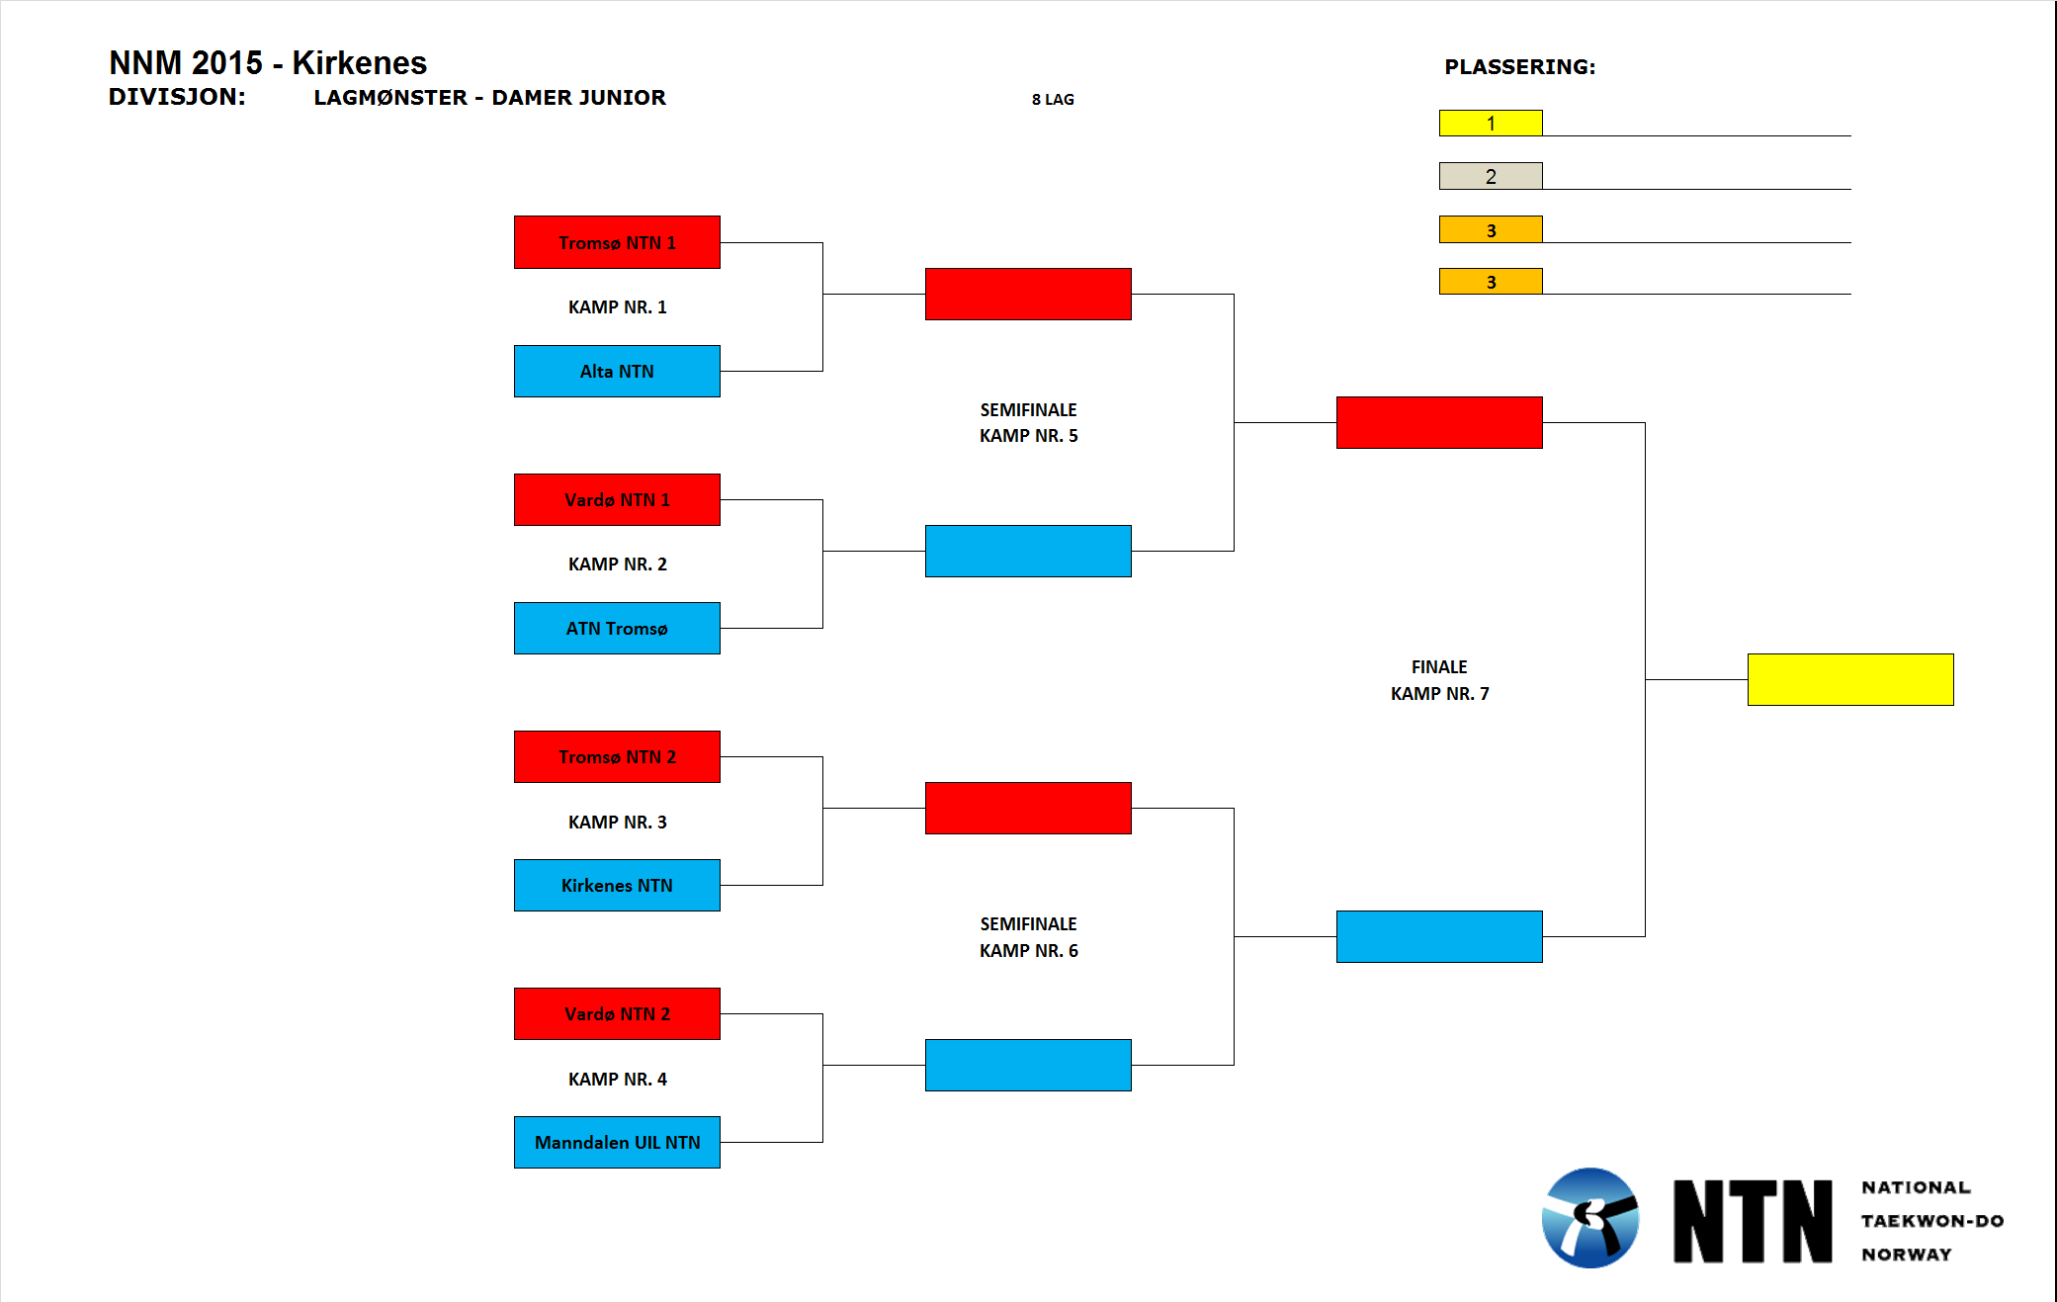

**Divisjon:** Lagmønster – herrer junior – **3 lag**

|  |  |
| --- | --- |
|  | **Lag** |
| **A** | Alta NTN |
| **B** | Kirkenes NTN |
| **C** | Tromsø NTN |

**Kamp nr. 1:**

A (rød) vs. B (blå)

**Kamp nr. 2:**

Vinneren av kamp nr. 1 (rød) møter C (blå).

**Kamp 3 (kun dersom C vinner):**

Taperen av kamp nr. 1 (rød) møter taperen av kamp nr. 2 (rød)

|  |  |
| --- | --- |
| **Resultat** | |
| **1** |  |
| **2** |  |

**Divisjon:** Lagmønster – herrer senior – **3 lag**

|  |  |
| --- | --- |
|  | **Lag** |
| **A** | Tromsø NTN |
| **B** | Kirkenes NTN |
| **C** | Alta NTN |

**Kamp nr. 1:**

A (rød) vs. B (blå)

**Kamp nr. 2:**

Vinneren av kamp nr. 1 (rød) møter C (blå).

**Kamp 3 (kun dersom C vinner):**

Taperen av kamp nr. 1 (rød) møter taperen av kamp nr. 2 (rød)

|  |  |
| --- | --- |
| **Resultat** | |
| **1** |  |
| **2** |  |

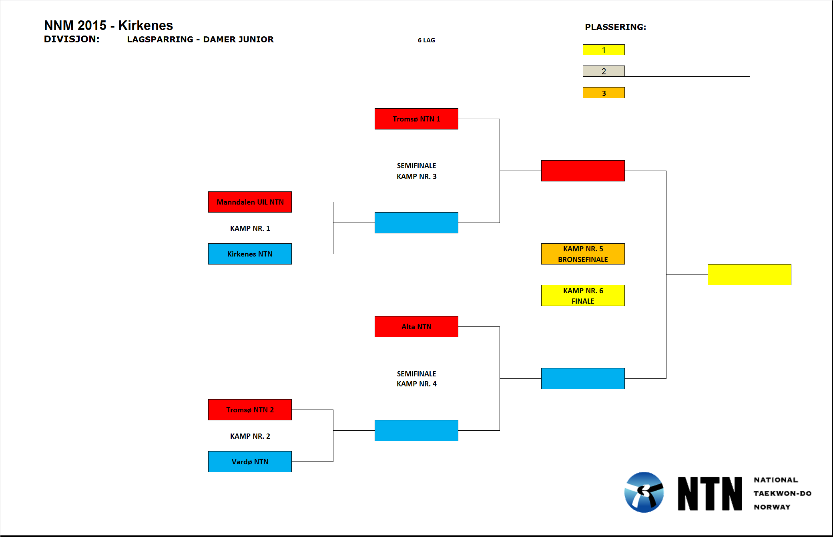

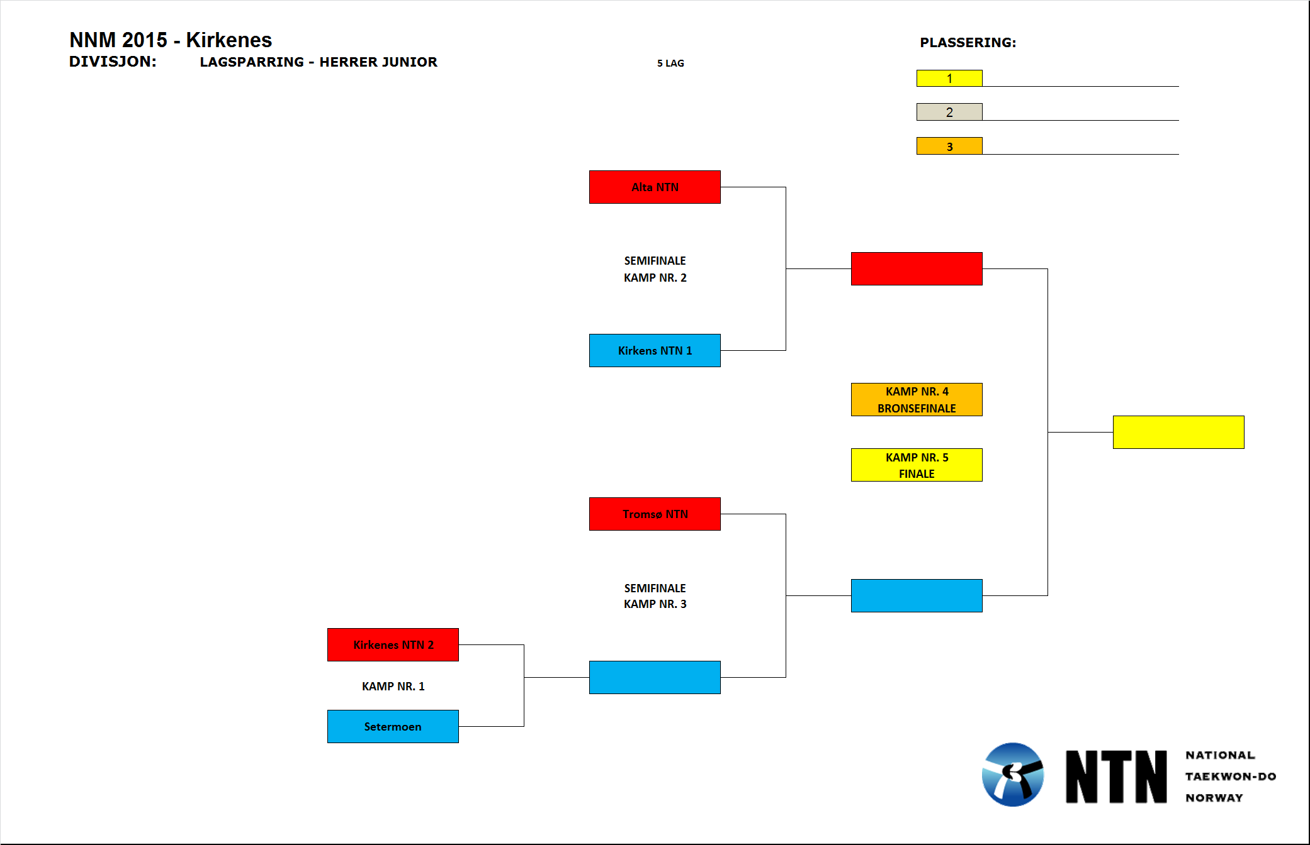

**Divisjon:** Lagsparring – herrer senior – **4 lag**

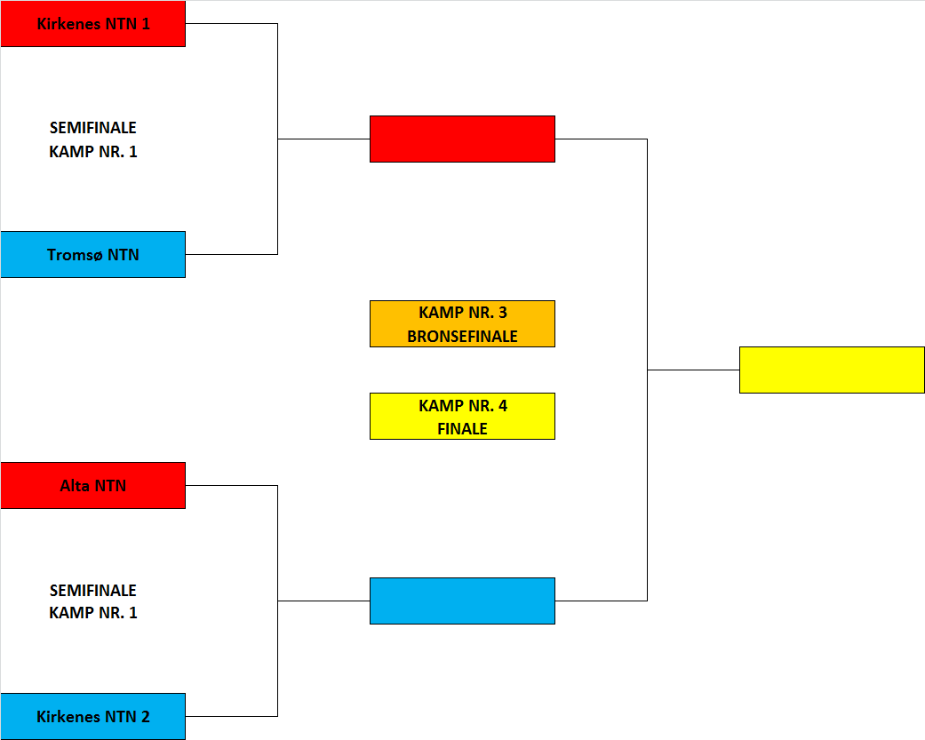

|  |  |
| --- | --- |
| **Resultat** | |
| **1** |  |
| **2** |  |
| **3** |  |